**[Relabeling a label matrix](http://blogs.mathworks.com/steve/2008/04/14/relabeling-a-label-matrix/" \o "Permanent Link to Relabeling a label matrix)**

The three most common questions I've been hearing about [bwlabel](http://www.mathworks.com/access/helpdesk/help/toolbox/images/bwlabel.html), which is used for labeling connected components in a binary image, are about

* Search order
* Relabeling (renumbering the label matrix)
* Correspondence between labels in two different images

Today I'll tackle relabeling.

In my [previous post on search order](http://blogs.mathworks.com/steve/2008/03/25/bwlabel-search-order/), I showed how to postprocess the labeled objects to modify their order according to various criteria. Now I'll take that a step further and use the sorted output from regionprops to renumber the labels in the label matrix.

Blog reader [Trung](http://blogs.mathworks.com/steve/2008/03/25/bwlabel-search-order/" \l "comment-20522) wanted to know if we could sort lexicographically by centroid, so I'll do that here.

url = 'http://blogs.mathworks.com/images/steve/186/scanned_page.png';

bw = imread(url);

bw = ~bw(1107:1194, 17:135);

imshow(bw, 'InitialMagnification', 'fit')

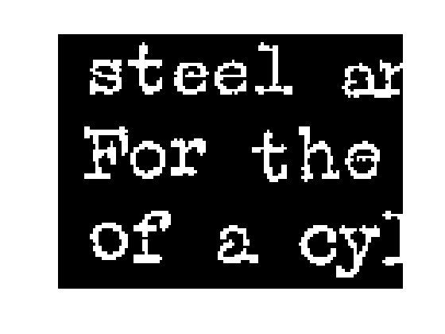

Here's a false-color view of the label matrix using [label2rgb](http://www.mathworks.com/access/helpdesk/help/toolbox/images/label2rgb.html):

L = bwlabel(bw);

rgb = label2rgb(L, 'jet', [.95 .95 .95], 'shuffle');

imshow(rgb, 'InitialMagnification', 'fit')

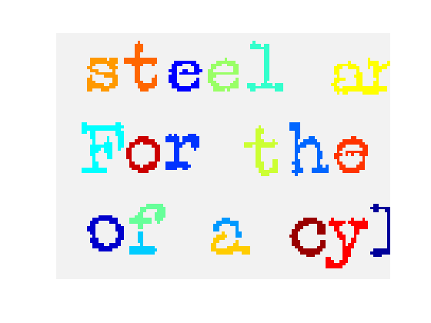

Now let's use regionprops to get the centroids for each object. To facilitate the relabeling step, I'll get the'PixelIdxList' for each object.

s = regionprops(L, {'Centroid', 'PixelIdxList'});

Next, sort lexicographically by the centroids, sorting first by the vertical coordinate.

centroids = cat(1, s.Centroid);

[sorted_centroids, sort_order] = sortrows(fliplr(centroids));

s2 = s(sort_order);

To visualize the sorted object order, we can display the object numbers on top of the objects like this:

% First, make an image with a light gray background instead

% of a black background, so that the numbers will be visible

% on top of it.

I = im2uint8(bw);

I(~bw) = 200;

I(bw) = 240;

imshow(I, 'InitialMagnification', 'fit')

% Now plot the number of each sorted object at the corresponding

% centroid:

hold on

for k = 1:numel(s2)

centroid = s2(k).Centroid;

text(centroid(1), centroid(2), sprintf('%d', k));

end

hold off

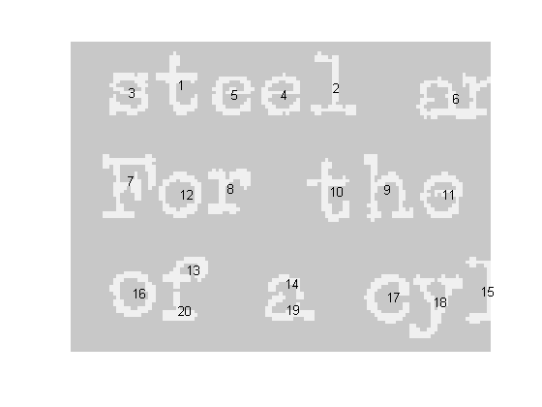

We sorted the output of regionprops, but we haven't touched the label matrix itself. We can relabel it according to the sort order by using linear indexing and the PixelIdxList of each object. An object'sPixelIdxList is a vector of linear indices for the pixels belonging to the object. Here's the relabeling loop:

for k = 1:numel(s2)

kth_object_idx_list = s2(k).PixelIdxList;

L(kth_object_idx_list) = k;

end

In MATLAB 7.6 (R2008a), the [publish](http://www.mathworks.com/access/helpdesk/help/techdoc/matlab_env/f6-22451.html) feature lets you capture multiple graphics from within a loop. I'll use that new capability to show the location of the first few relabeled objects in L.

for k = 1:5

imshow(L == k)

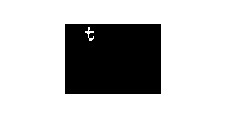 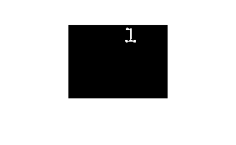  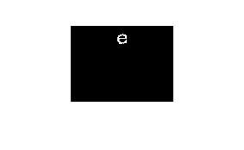 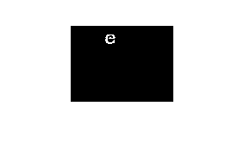

end

Soon I'll write another post that shows how how to match up labels in objects that overlap between two images.